NPCR: The encrypted image should greatly differ from its original form. In general, two difference measures are used to quantify this requirement. The first measure is the number of pixels change rate (NPCR), which indicate the percentage of different pixels between two images.
UACI: the unified average changing intensity (UACI), which measures the average intensity of differences in pixels between two images.
NPCR과 UACI 수식 설명: Let Io(i, j) and IENC(i, j) be the pixels values of original and encrypted images, Io and IENC, at the ith pixel row and jth pixel column, respectively.
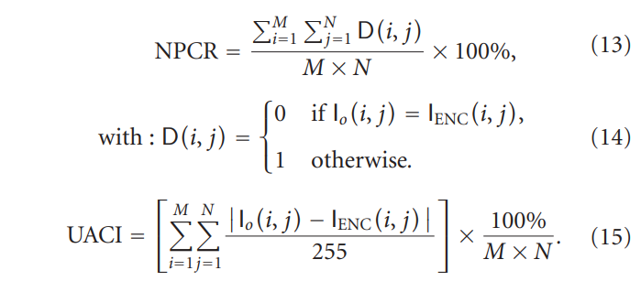
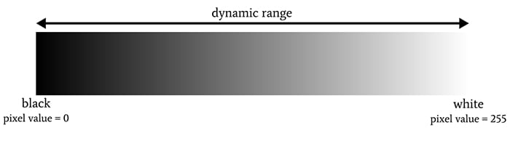

**추가: The number of changing pixel rate (NPCR) and the unified averaged changed intensity (UACI) are two most common quantities used to evaluate the strength of image encryption algorithms/ciphers with respect to differential attacks. Conventionally, a high NPCR/UACI score is usually interpreted as a high resistance to differential attacks.
출처: https://citeseerx.ist.psu.edu/viewdoc/download?doi=10.1.1.390.2127&rep=rep1&type=pdf

<암호화> S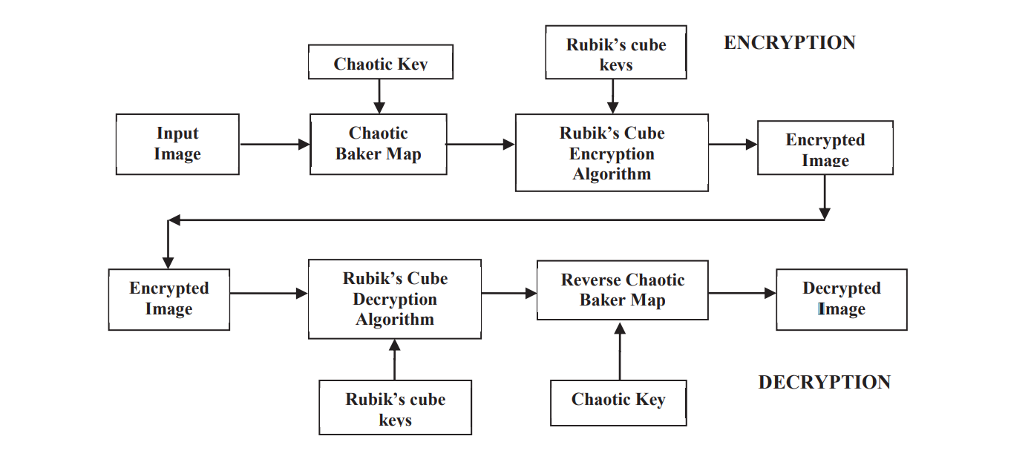출처: Secure Communication Based On Rubik’s Cube Algorithm And Chaotic Baker Map

